**Project Report**

**Team ID :** PNT2022TMID31845

**Project Title :** Smart Solutions For Railways

**1. INTRODUCTION**

**1.1 Project Overview**

The project aims at improving the railway management system which will be useful for authorities as well as to passengers. It includes different functions like controlling the speed of train based signals, it notifies about the problem in railway tracks and inform to the railway authorities via GSM and it can avoid derailment of train which causes the accident. Station alert SMS function is used in the project for the beneficial of passengers. The PIC Microcontroller is the heart of the project. The IR sensor is used for detecting the crack in the railway tracks. Once the crack has been detected, railway authorities will be notified via SMS and also the loco pilot of train within the coverage area which will further used to avoid accidents. The GPS is used to trace the location of the failure of railway track. The Fire Sensor is used to detect the fire in the train, once the fire is detected it will inform to the railway authorities and fire bridge for an emergency. In this project we are focusing on three important features of train which will be helpful further and overcome the existing system used for it. Deepening the informatization and intelligent construction of railways has become an inevitable choice to promote the innovation and development of railways and enhance their core competitiveness.At present,China has in-depth research in smart cities,smart transportation and other fields, but the research on smart railways is still in its infancy, and it is urgent to make plans for the development of smart railways to provide guiding suggestions for the development of railway informationization.Based on the research results of smart cities and smart transportation in related fields at home and abroad, combined with the application trends of internet technology and big data technology in railway informatization, this paper attempts to give a clear definition of smart railway from the perspective of smart city development.

**1.2 Purpose**

Transportation systems are complex with respect to technology and operations due to the involvement of a wide range of human actors, organisations and technical solutions. There is a need to apply intelligent computerised systems for the operation and control of such complex environments, such as computerised traffic control systems for coordinating advanced transportation.

Industry 4.0 is enabled by smart systems and Internet-based solutions. Maintenance is one of the application areas of self-learning, and smart systems can predict failure and trigger maintenance by making use of the Internet of things [(IoT)](https://www.metrorailnews.in/urban-transport-and-climate-change-role-of-rail-based-transport-system/).

There is no established path for success of any emerging technology, but creating a roadmap can help the rail and aviation industries to bring a more digital and connected future. The need for these industries to be smart is there because Industry 4.0, or the fourth generation of industrial activity, ensures reliability and safety to these sectors. With automation of the manufacturing industry, these sectors will realise efficiency, capacity and cost benefits of Industry 4.0. Enhanced industry-wide condition monitoring will also help reduce unplanned maintenance. Both sectors are in constant search for improvements to deliver better and secure customer experience.

The digital railway programme is focussed mainly on digital signalling technology, which aims to enhance safety and speed up train movement in a congested network. If all data from signalling, rolling stock and passenger traffic control systems is brought together on a common platform, the entire network will be able to communicate seamlessly and instantaneously. The key to digitisation is the interoperability of systems while retaining a critical approach to data security.

**2. LITERATURE SURVEY**

**2.1 Existing problem**

* Safety and security.
* Intermodality.
* Connectivity.
* Energy Consumption.
* Governance.
* Integrity and Social Recognition.

**2.2 References**

1. Mori, K., Christodoulou, A.: Review of sustainability indices and indicators: towards a new city sustainability index (CSI). Environ. Impact Assess. Rev. 32(1), 94–106 (2012)

2. Albino, V., Berardi, U., Dangelico, R.M.: Smart cities: deﬁnitions, dimensions, performance, and initiatives. J. Urban Technol. 22(1), 3–21 (2015)

3. Chen, T.M.: Smart grids, smart cities need better networks [Editor’s Note]. IEEE Netw. 24(2), 2–3 (2010)

4. Bakıcı, T., Almirall, E., Wareham, J.: A smart city initiative: the case of Barcelona.

J. Knowl. Econ. 4(2), 135–148 (2013)

5. Barrionuevo, J.M., Berrone, P., Ricart, J.E.: Smart cities, sustainable progress. IESE Insight 14(14), 50–57 (2012)

6. Hollands, R.G.: Will the real smart city please stand up? Intelligent, progressive or

entrepreneurial? City 12(3), 303–320 (2008)

7. Nam, T., Pardo, T.A.: Conceptualizing smart city with dimensions of technology, people, and institutions. In: Proceedings of the 12th Annual International Digital Government Research Conference: Digital Government Innovation in Challenging Times, pp. 282–291.ACM (June 2011).

8. Shapiro, J.M.: Smart cities: quality of life, productivity, and the growth effects of human capital. Rev. Econ. Stat. 88(2), 324–335 (2006)

9. Mahizhnan, A.: Smart cities: the Singapore case. Cities 16(1), 13–18 (1999)

10. Gifﬁnger, R., Pichler-Milanović, N.: Smart cities: ranking of European medium-sized cities. Centre of Regional Science, Vienna University of Technology (2007)

11. Alawadhi, S., Aldama-Nalda, A., Chourabi, H., Gil-Garcia, J.R., Leung, S., Mellouli, S.,

Nam, T., Pardo, T.A., Scholl, H.J., Walker, S.: Building understanding of smart city

initiatives. In: International Conference on Electronic Government, pp. 40–53. Springer,

Heidelberg (September 2012)

12. Lombardi, P., Giordano, S., Farouh, H., Yousef, W.: Modelling the smart city performance. Innov.: Eur. J. Soc. Sci. Res. 25(2), 137–149 (2012)

13. Chowdhary, M.A., Sadek, A.: Fundamentals of Intelligent Transportation Systems Planning. Artech House Inc., US (2003)

14. Williams, B.: Intelligent transportation systems standards. Artech House, London (2008) Key Challenges of Smart Railway Station 293

15. Bocchetti, G., Flammini, F., Pragliola, C., Pappalardo, A.: Dependable integrated

surveillance systems for the physical security of metro railways. In: 2009 Third

ACM/IEEE International Conference on Distributed Smart Cameras (ICDSC), pp. 1–7.

IEEE (August 2009)

16. Ulianov, C., Hyde, P., Shaltout, R.: Railway applications for monitoring and tracking

systems. In: Sustainable Rail Transport, pp. 77–91. Springer, Cham (2018)

17. Pachauri, R.K., Allen, M.R., Barros, V.R., Broome, J., Cramer, W., Christ, R., Church, J.A.,Clarke, L., Dahe, Q., Dasgupta, P., Dubash, N.K.: Climate change 2014: synthesis report. Contribution of Working Groups I, II and III to the Fifth Assessment Report of the

Intergovernmental Panel on Climate Change, p. 151. IPCC (2014)

18. González-Gil, A., Palacin, R., Batty, P.: Sustainable urban rail systems: strategies and

technologies for optimal management of regenerative braking energy. Energy Convers.

Manag. 75, 374–388 (2013)

19. Şengör, İ,Kılıçkıran, H.C., Akdemir, H., Kekezoǧlu, B., Erdinc, O., Catalao, J.P.: Energy management of a smart railway station considering regenerative braking and stochastic behaviour of ESS and PV generation. IEEE Trans. Sustain. Energy 9(3), 1041–1050 (2017)

20. Collotta, M., Pau, G.: An innovative approach for forecasting of energy requirements to improve a smart home management system based on BLE. IEEE Trans. Green Commun. Netw. 1(1), 112–120 (2017)

21. Meijer, A., Bolívar, M.P.R.: Governing the smart city: a review of the literature on smart urban governance. Int. Rev. Adm. Sci. 82(2), 392–408 (2016)

22. Chourabi, H., Nam, T., Walker, S., Gil-Garcia, J.R., Mellouli, S., Nahon, K., Pardo, T.A.,

Scholl, H.J.: Understanding smart cities: an integrative framework. In: 2012 45th Hawaii

International Conference on System Sciences, pp. 2289–2297. IEEE (January 2012)

23. Bătăgan, L.: Smart cities and sustainability models. Informatica Economică15(3), 80–87(2011)

24. Pereira, G.V., Parycek, P., Falco, E., Kleinhans, R.: Smart governance in the context of

smart cities: a literature review. Inf. Polity 23(2), 143–162 (2018)

**2.3 Problem Statement Definition**

1) Automatic braking system and alarming based on health monitoring of locomotive pilot

2) Interconnecting lights with sensor for automatic switching on and off to save power

3) Connecting Air Conditioners in AC coaches with temperature sensor which regulates and adapts to the temperature conditions.

4) Fire alarm intimation to the locomotive pilot and automatic water sprayer in case of any fire in the passenger cars. Also provides alert to the nearby Fire station

5) Automatic platform allotment in large stations

6) Automatic train traffic control

7) QR scanner based ticket checking and automatic door opening

8) Wake up call/alert to the user on nearing the destination

9) Automatic Railway crossing barricade system

10) Enhanced and automated waiting list queue clearance.

**3. IDEATION & PROPOSED SOLUTION**

**3.1 Empathy Map Canvas**

An empathy map is a simple, easy-to-digest visual that captures knowledge about a user’s behaviours and attitudes. It is a useful tool to helps teams better understand their users. Creating an effective solution requires understanding the true problem and the person who is experiencing it. The exercise of creating the map helps participants consider things from the user’s perspective along with his or her goals and challenges.

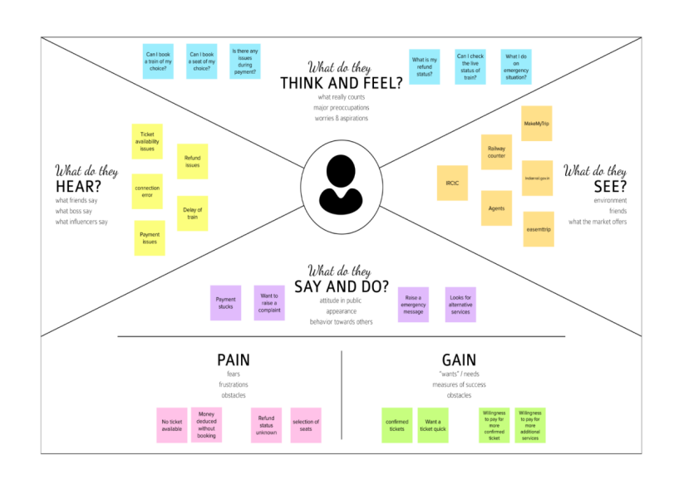

**3.2 Ideation & Brainstorming**

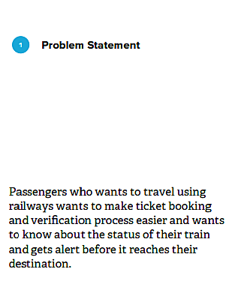

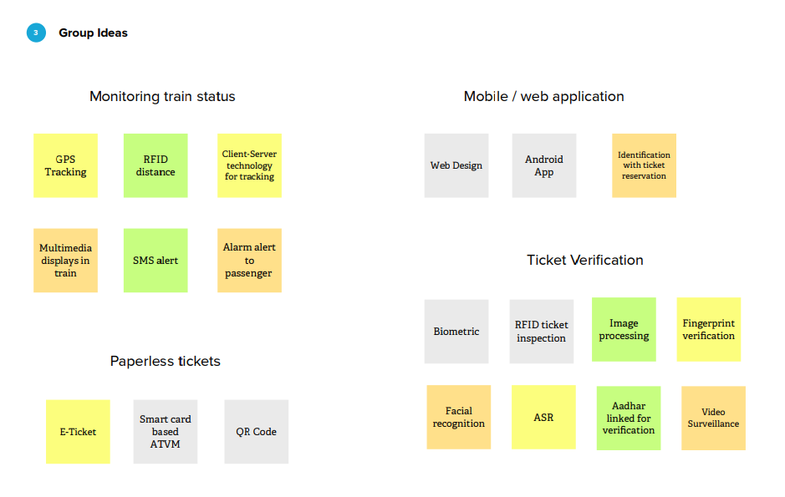

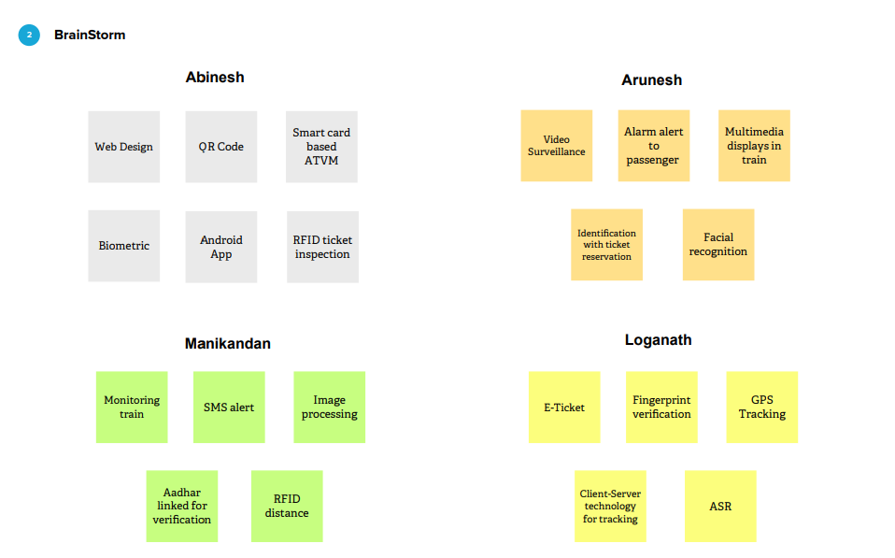

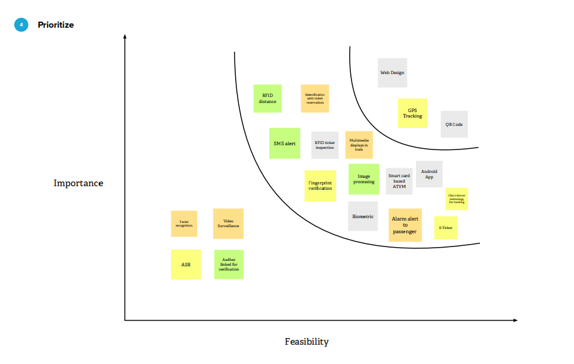

**3.3 Proposed Solution**

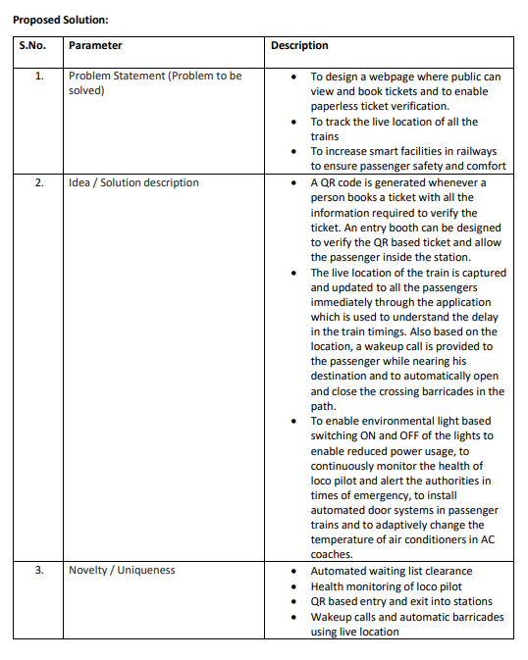

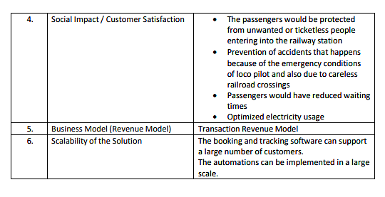

**3.4 Problem Solution fit**

This paper provides analysis of supply chain management framework in the public procurement environment through a case study of the Indian railway. The paper provides some insights about the evolution of supplier relationship management and its impact on key performance indicators. Its also provides an integrative framework for management of public procurement. The paper builds on extensive review of literature and follows a case study methodology. The unit of analysis is the Indian Railway’s material management function. Analysis uses data of over a period of five years. The finding highlights that supplier relationships with the Indian railway have been geared around arms-length philosophy. The current symptoms of inefficiencies are reflected in high cycle time, high costs associated with supplier selection process, poor accountability, blurring of responsibility and poor value creation for all the stakeholders. The current procurement mechanisms are not crafted around development of long term strategic partnerships. This study is filling the gaps in literature by presenting the challenges of supply chain management in the public procurement environment.

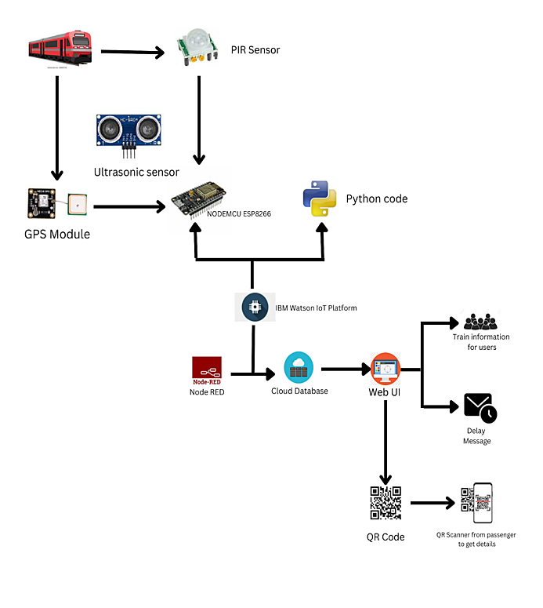

**4. REQUIREMENT ANALYSIS**

**4.1 Functional requirement**

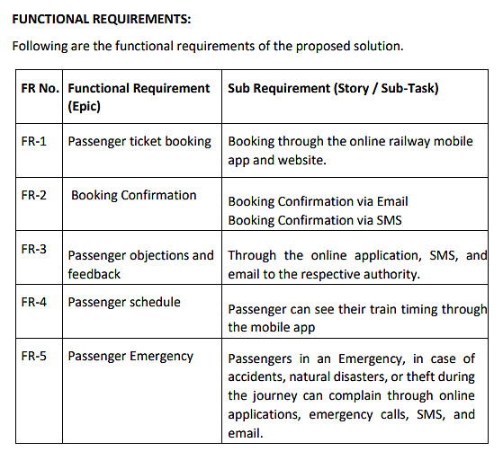

**4.2 Non-Functional requirements**

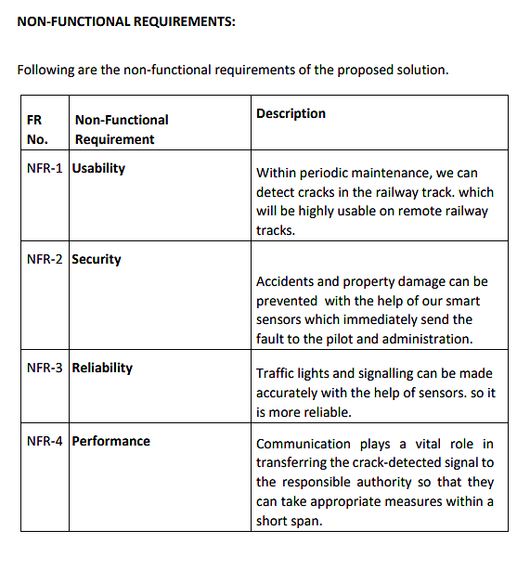

**5. PROJECT DESIGN**

**5.1 Data Flow Diagrams**

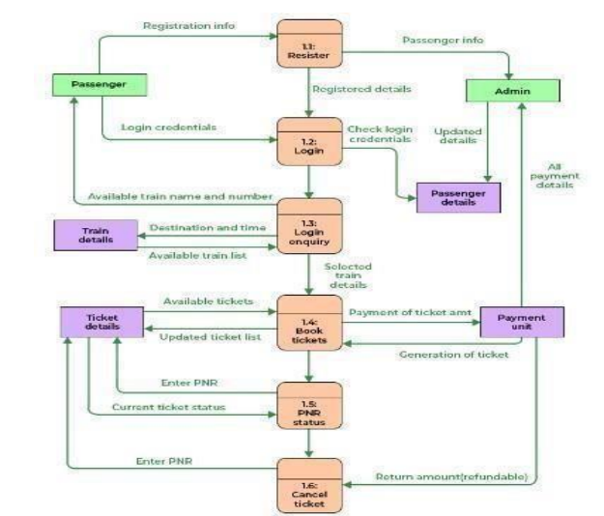

**5.2 Solution & Technical Architecture**

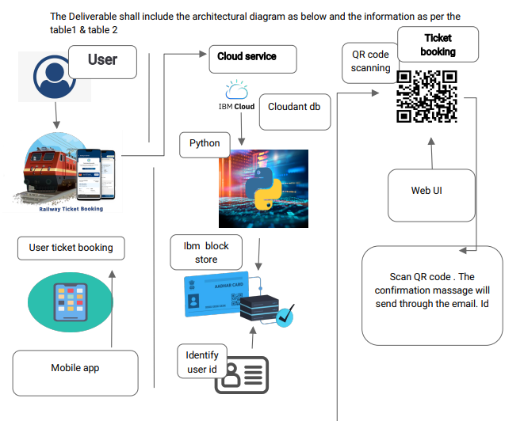

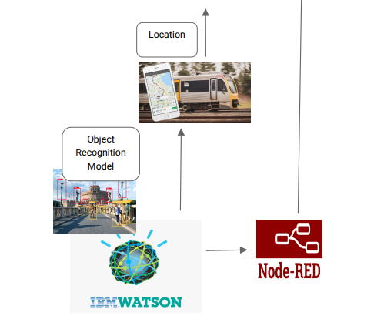

**5.3 User Stories**

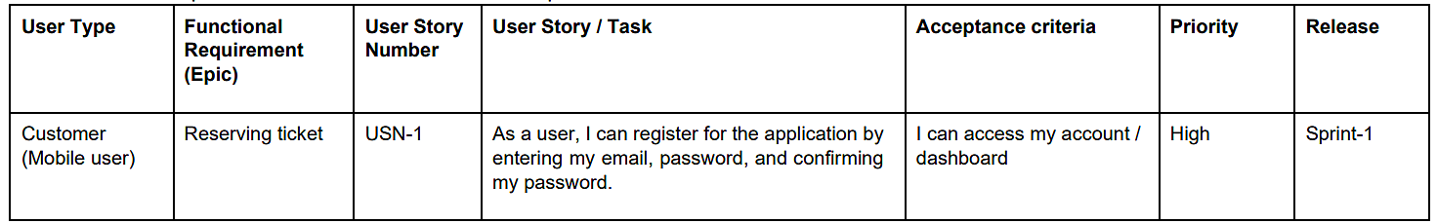

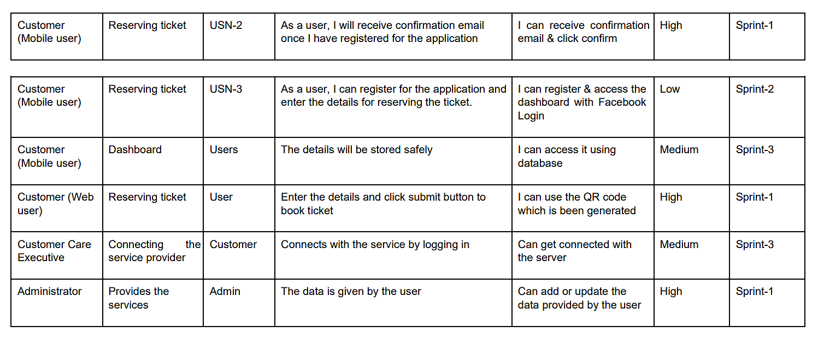

**6. PROJECT PLANNING & SCHEDULING**

**6.1 Sprint Planning & Estimation**

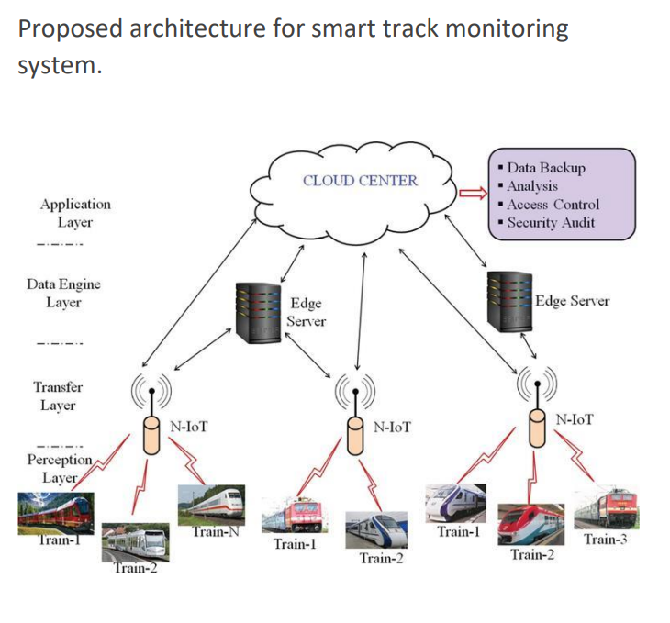

**6.2 Sprint Delivery Schedule**

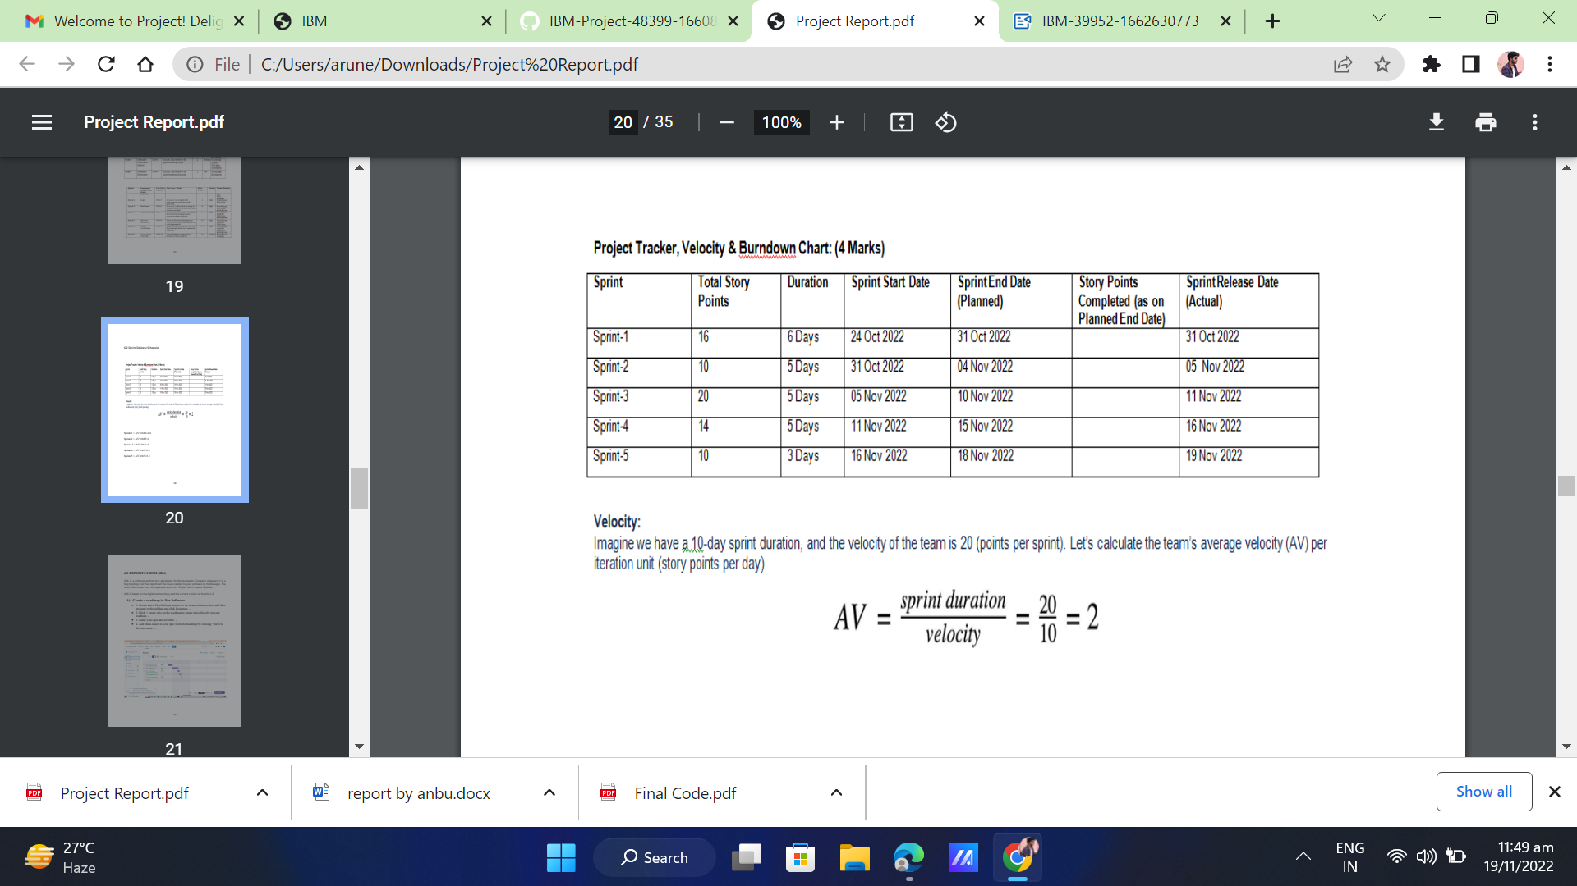

Sprint-1 = AV=16/06=2.6

Sprint-2 = AV=10/05=2

Sprint -3 = AV=20/5=4

Sprint-4 = AV=14/5=2.8

Sprint-5 = AV=10/3=3.3

**6.3 REPORTS FROM JIRA**

JIRA is a software testing tool developed by the Australian Company Atlassian. It is a bug tracking tool that reports all the issues related to your software or mobile apps. The word JIRA comes from the Japanese word, i.e., "Gojira" which means Godzilla.

JIRA is based on the Agile methodology and the current version of the Jira is 6.

**A) Create a roadmap in Jira Software**

• 1. Create a new Jira Software project or go to an existing project and then navigate to the sidebar and click Roadmap. ...

• 2. Click + create epic on the roadmap to create epics directly on your roadmap. ...

• 3. Name your epic and hit enter. ...

• 4. Add child-issues to your epic from the roadmap by clicking + next to the epic name. ...

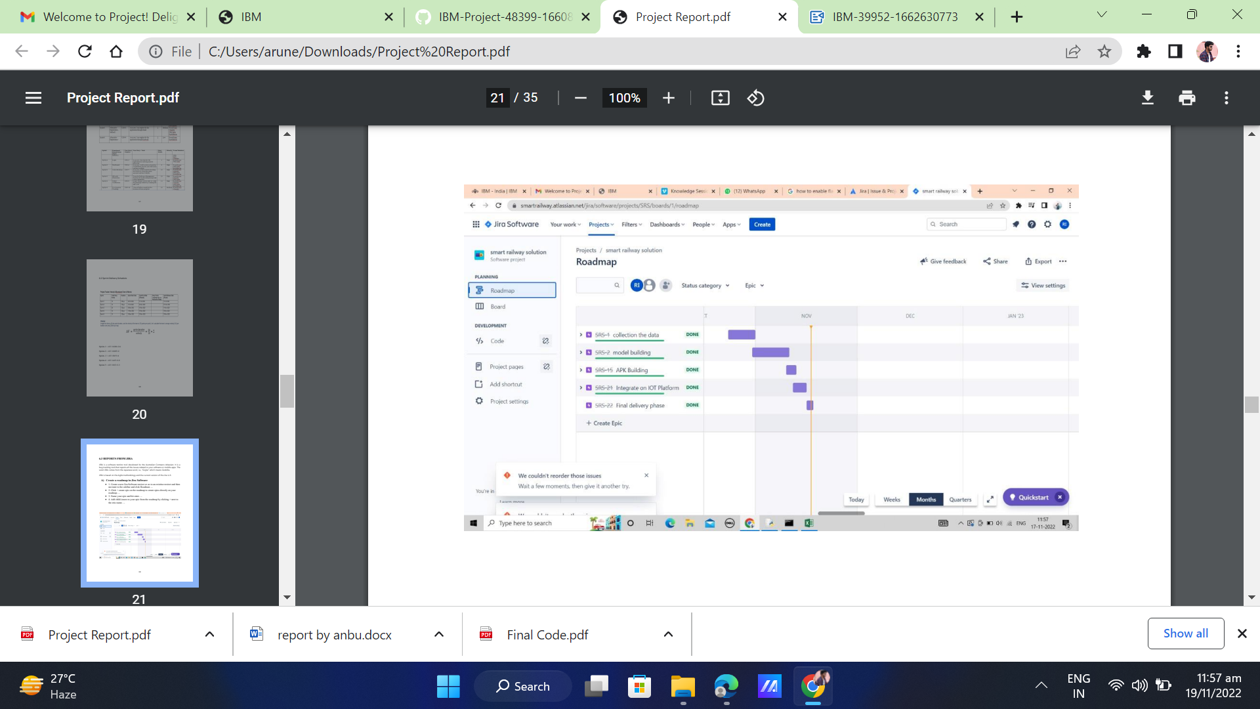

**TESTING**

7.1 Test case:

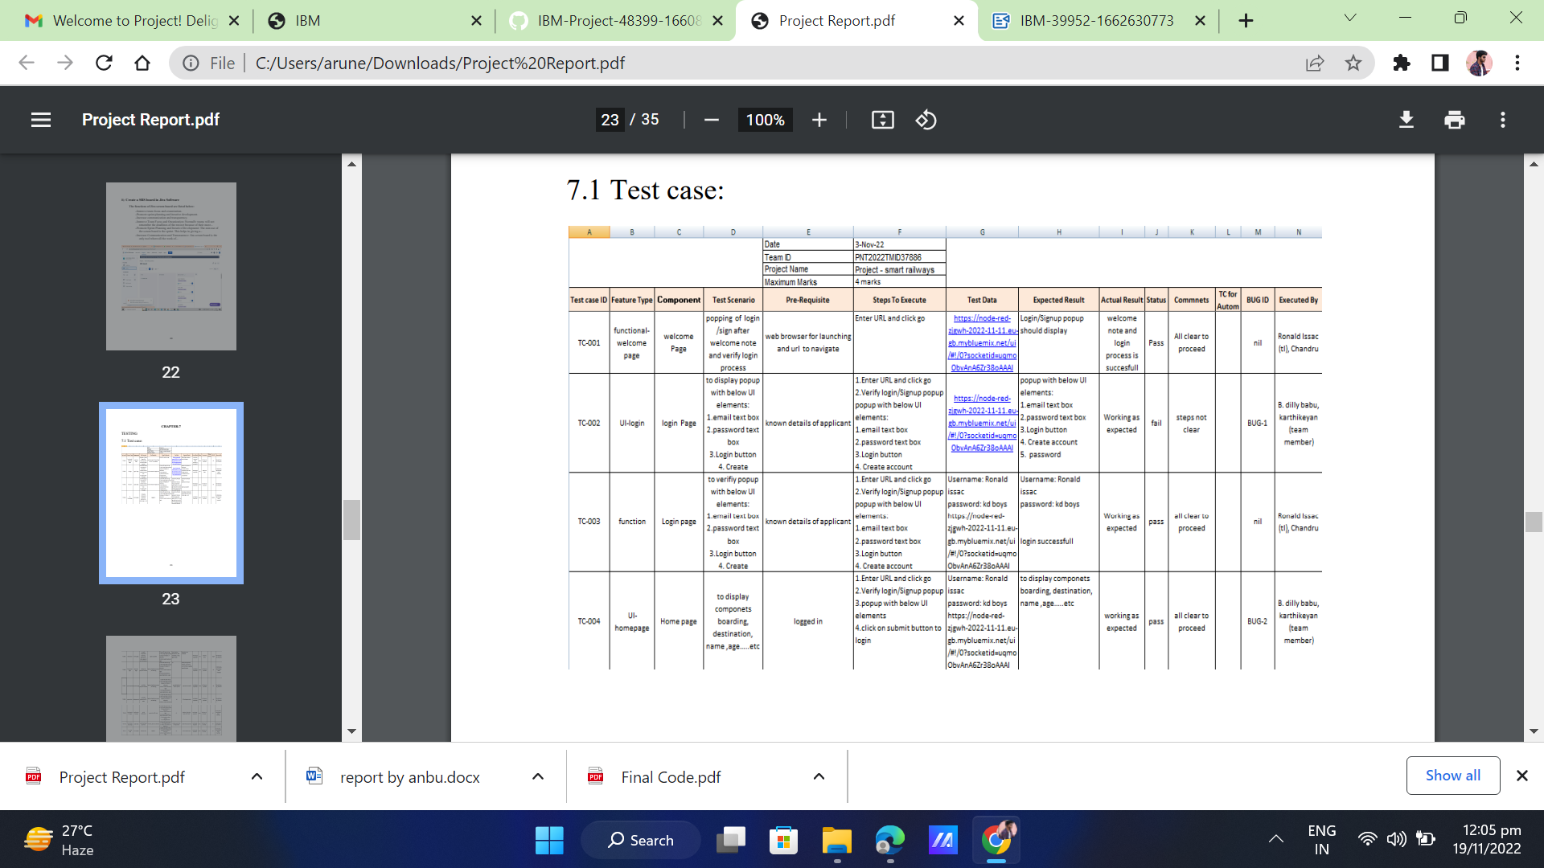

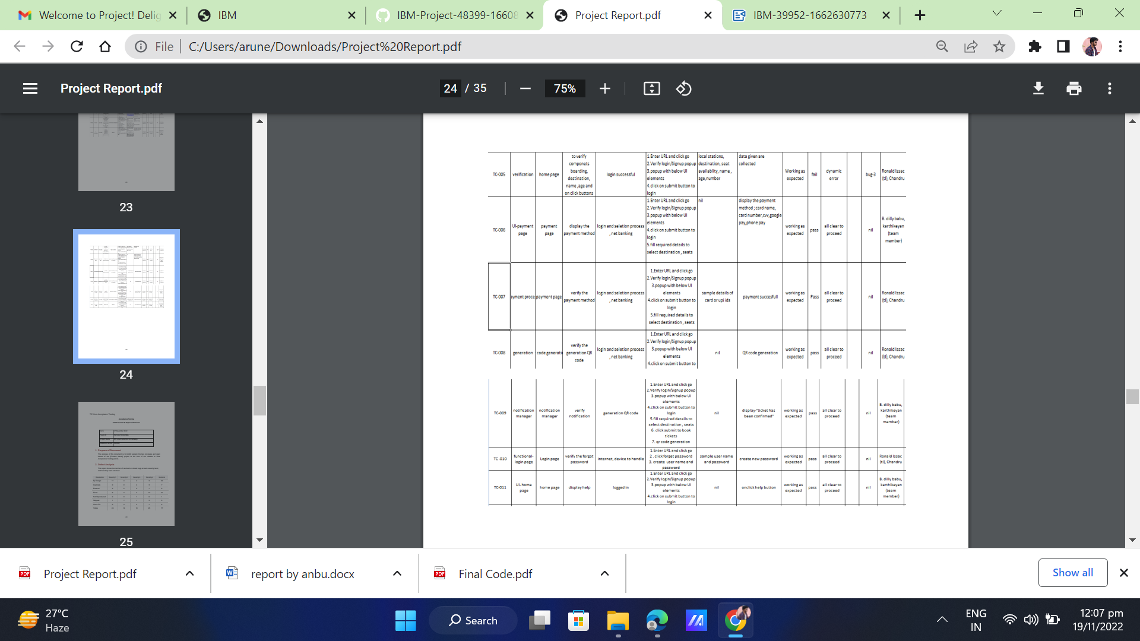

**7.2 User Acceptance Testing**

Acceptance Testing

UATExecution & Report Submission

|  |  |
| --- | --- |
| Date | 17 November 2022 |
| Team ID | PNT2022TMID31845 |
| Project Name | IOT-smart solution for railways |
| Maximum Marks | 4 Marks |

## Purpose of Document

The purpose of this document is to briefly explain the test coverage and open issues of the [ProductName] project at the time of the release to User Acceptance Testing (UAT).

## Defect Analysis

This reportshows the numberof resolved or closed bugs at each severity level, and how theywere resolved

|  |  |  |  |  |  |
| --- | --- | --- | --- | --- | --- |
| **Resolution** | **Severity1** | **Severity2** | **Severity3** | **Severity4** | **Subtotal** |
| ByDesign | 11 | 4 | 2 | 3 | 20 |
| Duplicate | 0 | 0 | 4 | 3 | 7 |
| External | 3 | 2 | 0 | 1 | 6 |
| Fixed | 9 | 4 | 3 | 15 | 31 |
| NotReproduced | 0 | 0 | 1 | 0 | 1 |
| Skipped | 1 | 1 | 1 | 3 | 6 |
| Won't Fix | 0 | 3 | 2 | 1 | 6 |
| Totals | 24 | 14 | 14 | 26 | 77 |

## Test Case Analysis

Thisreport shows the number of test casesthat have passed, failed , and untested

|  |  |  |  |  |
| --- | --- | --- | --- | --- |
| **Section** | **Total Cases** | **Not Tested** | **Fail** | **Pass** |
| Functional | 2 | 0 | 0 | 2 |
| UI | 2 | 0 | 0 | 2 |
| Verification | 1 | 0 | 0 | 1 |
| Notification manager | 1 | 0 | 0 | 1 |
| Payment process | 1 | 0 | 0 | 1 |
| Generation | 1 | 0 | 0 | 1 |

**8.RESULTS**

* 1. Performance metrics

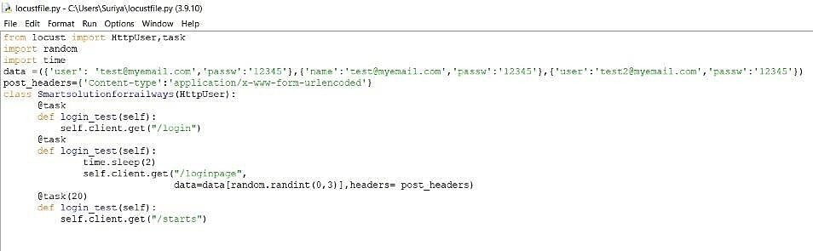

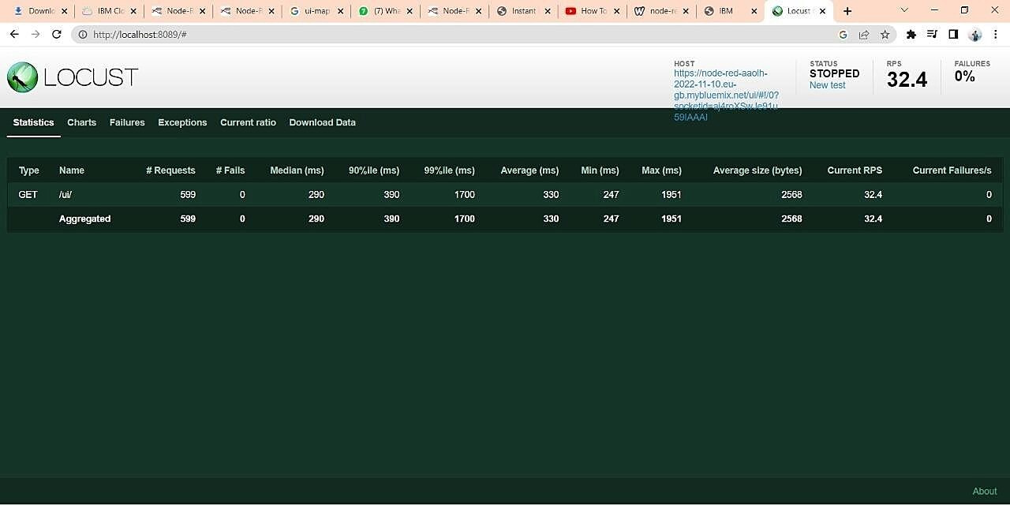

# 

# 9. ADVANTAGES & DISADVANTAGES

**ADVANTAGES:**

* + - Better organized
    - Suitable for longer journeys
    - Promotes tourism
    - Less Time consume
    - Less employee wages

# DISADVANTAGES:

* Highly inflexible
* Costly if the routes are small
* Train parts are pretty old
* Unsuitable for perishable and fragile items
* Generates unemployment

# 

# 

**10.Conclusion**

Thus, we have completed our paper “Planning, analyzing and designing of Smart railway station” successfully. The station is designed with standard basic requirements according to Indian railways rules and regulations. Due to increasein population, the rail transporttends to increasebecause of its low economy among the people. So for reducing the cost of purchasing additional land it needs to alter the existing structures into multi story building in which we can provide additional facilities for passengers, handicapped persons, transgender persons, porters and employees. This will help in maintenance and monitoring the condition of railway tracks without any errors and thereby maintaining the tracks in good condition, preventing train accidents to very large extent Railway trackcrack detection autonomous vehicle.

**11.Future Scope**

1. Supervision of mechanical systems such as running gear and track.Identifying where problems arise on the track could significantly improvesafety.
2. Train doors could be monitored to see if they are properly closed. However, this would require operational changes as well, since passengers often leave doors open or even cling to the outside of the trainin case of overloaded trains.
3. Warning systems (light/acoustic) in case a train nears areas which are prone to accidents with people crossing the tracks.
4. Monitoring of bridgesregarding material stressor dynamic behaviorto detect changesindicating future failure.
5. Monitoring the speed of trains by GPS-driven speed measurements. Evaluating the speed profiles to validate the adherence of drivers to speed limits, but also to have real time trainlocation to optimize traffic.

**12.APPENDIX**

Source code

GPS module :

# Import common libraries

import numpy as np import

pandas as pd import matplotlib.pyplot as plt

# Import the PyGeohydro libaray

tools import pygeohydro as gh

from pygeohydro import SSFR, plot

# Use the smart solution for railways(SSFR)

ssfr = SSFR() # Specify date range of

interest dates = ("2020-01-01", "2020-12-

31")

# Filter stations to have only those with proper dates

stations = info_box[(info_box.begin_date <= dates[0]) & (info_box.end_date >= dates[1])].site_no.tolist()

# Remove duplicates by converting to

a set stations = set(stations) # Specify

characteristics of interest

select_attributes = journey time ,train announcement ,

waiting arrangement ,security in the station, seat condition

#Initialize a storage matrix

nldi_data = np.zeros((len(flow_data.columns), len(select_attributes)))

# Loop through all gages, and request NLDI data near each gage for i, st in enumerate(flow_data.columns):

# Navigate up all

flowlines from gage flowlines = NLDI().navigate_byid(fsource = 'nwissite',

fid = f'{st}',

navigation="upstreamTributaries" ,

source = 'flowlines', distance =

10)

# Get the nearest comid

station_comid = flowlines.nhdplus_comid.to_list()[0]

# Source NLDI local data

nldi_data[i,:] = NLDI().getcharacteristic_byid(station_comid, "local", char_ids = select_attributes)

**Git Hub project link:-**

https://github.com/IBM-EPBL/IBM-Project-39952-1660571878